**NAME:** M. AKSHITHA

**REGISTRATION NO:**192211709

**SUBJECT CODE:** CSA1024

**SUBJECT:** SOFTWARE ENGINEERING FOR INDUSTRIAL APPLICATION

**INDEX:**

|  |  |  |
| --- | --- | --- |
| S.NO | EXPERIMENT NAME | PAGE NO: |
| 1 | USE-CASE diagram for Online voting system |  |
| 2 | USE-CASE diagram for Library management system |  |
| 3 | USE-CASE diagram for Quotient and remainder |  |
| 4 | USE-CASE diagram for Online shopping |  |
| 5 | USE-CASE diagram for Railway Reservation System |  |
| 6 | USE-CASE diagram for Hospital Management System |  |
| 7 | USE-CASE diagram USE-CASE diagram for ATM System |  |
| 8 | USE-CASE diagram for Online College Management System |  |
| 9 | USE-CASE diagram for Online Airline Reservation System |  |
| 10 | Class Diagram For online Airline Reservation System |  |
| 11 | Class Diagram For Online Voting System |  |
| 12 | Class Diagram For Library Management System |  |
| 13 | Class Diagram For online Shopping System |  |
| 14 | Class Diagram For online Railway Reservation System |  |
| 15 | Activity Diagram For Online Voting System |  |
| 16 | Activity Diagram For Library Management System |  |
| 17 | Activity Diagram For Online Shopping System |  |
| 18 | Activity Diagram For Online Railway Reservation System |  |
| 19 | Activity Diagram For Hospital Management System |  |
| 20 | Palindrome or not |  |
| 21 | Fibonacci series |  |
| 22 | Swap two characters |  |
| 23 | Length of the string |  |
| 24 | Whether the given number prime or not |  |
| 25 | Cyclomatic complexity |  |

**1.USE-CASE Diagram For Online Voting System**

AIM:

TO IMPLIMENT AND EXECUTE ONLINE VOTING SYSTEM

**OBJECTIVES:**

Online Voting is a web-based voting system that will help you manage your elections easily and securely. This voting system can be used for casting votes during the elections held in colleges, etc. In this system the voter do not have to go to the polling booth to cast their vote. They can use their personal computer to cast their votes. There is a database which is maintained in which all the name of the voters with their complete information is stored. The System Administrator registers the voters by simply filling a registration form to register the voters. After registration, the voter is assigned a secret voter ID with which he/she can use to login to the system and cast his/her vote. If invalid/wrong details are submitted, then the person is not registered to vote. After the user successfully registers themselves, a link is sent on their respective E-mail IDs. The link is a key for the activation of the account of the user. The account is activated only after the user clicks on that link. The site will be activated only on the day of voting. Once the user logs in, they will be provided with a One Time Password (OTP) which has to be entered by the user before casting his/her vote. The password will be destroyed after casting of their respective vote. A receipt of the vote will be sent to the user on their respective E-mail IDs. The advantage of online voting is that the voters have the choice of voting at their own free time and there is reduced congestion. It also minimizes on errors of vote counting. The individual votes are submitted in a database which can be queried to find out who of the aspirants for a given post has the highest number of votes.

**PROCEDURE:**

*Arrange The Following characteristics

*Place persons at one side

*The elliptical shaped orbits place it in order

*Now give arrow ray to the characteristics

**OUTPUT:**

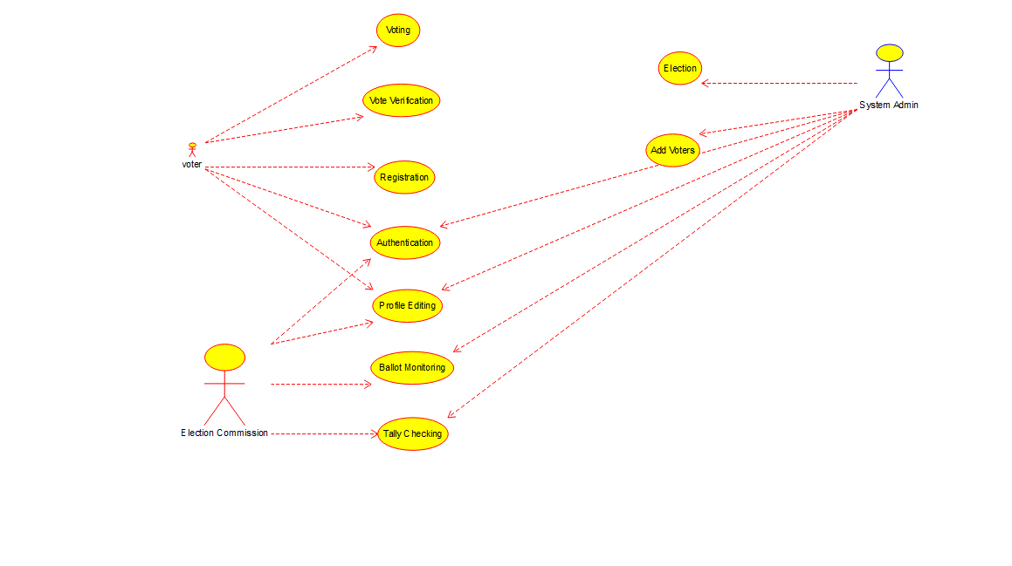

**RESULT:**

Thus, The Program Executed Successfully

**2.** USE-CASE diagram for Library Management System

**AIM:**

TO IMPLEMENT AND EXECUTE LIBRARY MANAGEMENT SYSTEM

**OBJECTIVES:**

A library management system is software that is designed to manage all the functions of a library. It helps librarian to maintain the database of new books and the books that are borrowed by members along with their due dates.

This system completely automates all your library’s activities. The best way to maintain, organize, and handle countless books systematically is to implement a library management system software.

A library management system is used to maintain library records. It tracks the records of the number of books in the library, how many books are issued, or how many books have been returned or renewed or late fine charges, etc.

You can find books in an instant, issue/reissue books quickly, and manage all the data efficiently and orderly using this system. The purpose of a library management system is to provide instant and accurate data regarding any type of book, thereby saving a lot of time and effort

**PROCEDURE:**

*Arrange The Following characteristics

*Place persons at one side

*The elliptical shaped orbits place it in order

*Now give arrow ray to the characteristics

**OUTPUT:**

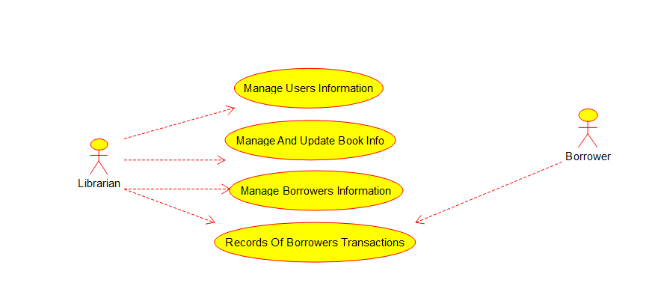

**RESULT:**

Thus, The Program Executed Successfully

**3.** Draw And Validate The Flowchart To Compute The Quotient And Remainder

**AIM:**

TO IMPLEMENT AND EXECUTE QUOTIENT AND REMAINDER

**OBJECTIVES:**

Raptor allows the user to write and execute the program using flowcharts. The simple language and geographical components of raptor are designed to teach the major ideas of computer programming to the students .it is typically used in academics to teach introductory programming as well

**PROCEDURE:**

**STEP 1:** From the raptor software application dragging the icons of assignment input and output

**STEP 2:** Iam taking 5 assignments ,1 input and 2 output and 2 loop for the effective running of the program

**STEP 3:** Filling the assignment, input and output and loop columns to run the code and entering the 2 value to run the program

**OUTPUT:**

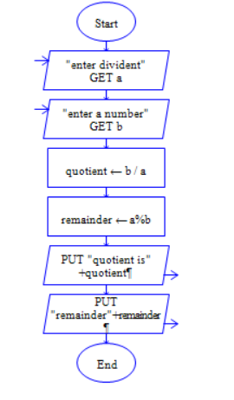

**RESULT:**

Finally the program is executed successfully

**4.USE-CASE DIAGRAM FOR ONLINE SHOPPING SYSTEM**

**AIM:**

TO IMPLEMENT AND EXECUTE ONLINE SHOPPING SYSTEM

**OBJECTIVES:**

 Use Case are intended to provide all stakeholders, including clients and project managers as well as develops and engineers, with a high-level view of the subject system and communicate the highest level system requirements in non-technical terms.

The purpose of use case diagrams is to model what the system should do without considering how it should be done at this stage ) and to view the use of the system from the user's perspective (**external view**) rather than internally (**implementation of these features).**

Use Case diagrams have only 4 major elements:

1. The **actors** that the system you are describing interacts with:
2. The **system**itself (system boundary - the rectangle)
3. The **use cases**, or services, that the system knows how to perform, and
4. The lines **(link)** that represent relationships between these elements.

**PROCEDURE:**

*Arrange The Following characteristics

*Place persons at one side

*The elliptical shaped orbits place it in order

*Now give arrow ray to the characteristics

**OUTPUT:**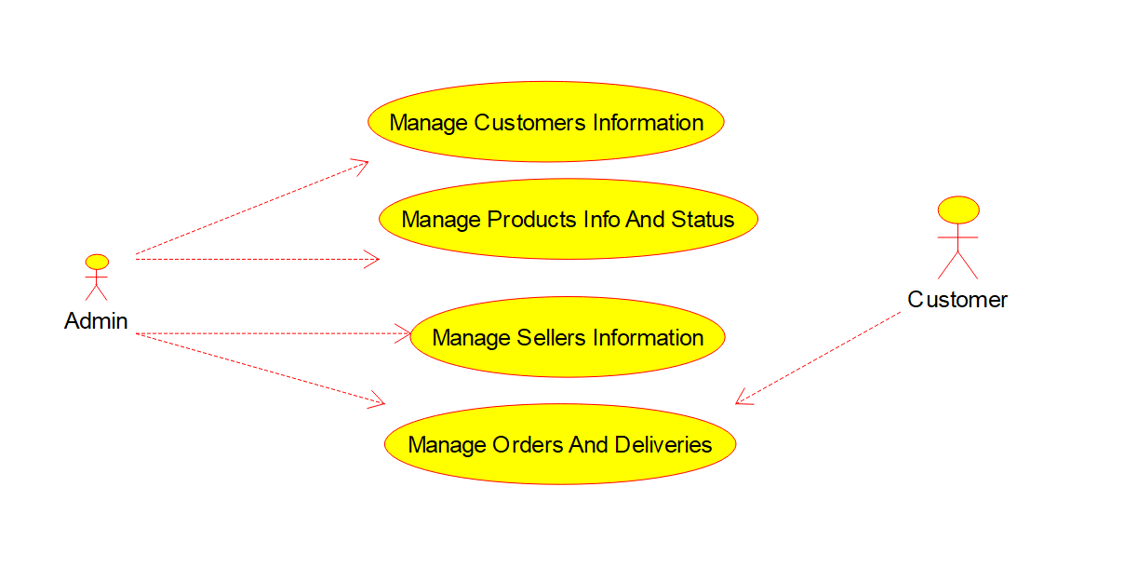

**RESULT:**

USE-CASE Diagram for online shopping system Successfully Completed

**5.**USE-CASE Diagram for Online Railway Reservation System

**AIM:**

TO IMPLEMENT AND EXECUTE THE ONLINE RAILWAY RESERVATION SYSTEM

**OBJECTIVES:**

Railway ticket booking system is implemented by [C programming](https://www.geeksforgeeks.org/c/). It is as same as one can see while we are going for online ticket booking. The following series of steps are being followed while booking a railway ticket in this software-

1. The first step is to provide the total number of passengers and submit all the necessary details of the passengers.
2. The next step is to enter the source and destination.
3. A list of available trains will appear. Among them, the user has to choose one.
4. The ticket value will be evaluated. The system will ask to enter the seat choice by showing the seat matrix. At last, a receipt will be generated on the screen.

DFD graphically speaking to the capacities, or cycles, which catch, control, store, and convey information between a framework and its current circumstance and between segments of a framework. The visual portrayal makes it a decent specialized device among User and System creator. Structure of DFD permits beginning from a wide outline and extend it to an order of definite charts. DFD has regularly been utilized because of the accompanying

**PROCEDURE:**

*Arrange The Following characteristics

*Place persons at one side

*The elliptical shaped orbits place it in order

*Now give arrow ray to the characteristics

**OUTPUT:**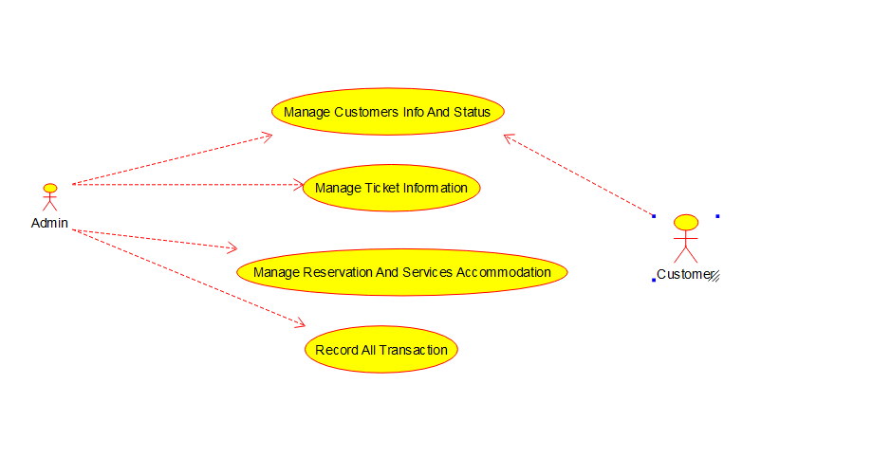

**RESULT:**

USE-CASE Diagram for Online Railway Reservation System successfully completed

**6.**USE-CASE Diagram For Hospital Management System

**AIM:**

TO IMPLIMENT AND EXECUTE THE HOSPITAL MANAGEMENT SYSTEM

**OBJECTIVES:**

HMS was introduced to solve the complications coming from managing all the paper works of every patient associated with the various departments of hospitalization with confidentiality. HMS provides the ability to manage all the paperwork in one place, reducing the work of staff in arranging he paperwork of the patients. HMS does many works like:

* Maintain the medical records of the patient
* Maintain the contact details of the patient
* Keep track of the appointment dates
* Save the insurance information for later reference

Tracking the bill payments

The implementation of hospital management system project provides the institution with different advantages that improve the service quality and efficiency. As mentioned above it is created for three groups of users: patients, hospital staff and management, and third-parties like drug suppliers and insurance companies. The interaction between them conveys the general performance. The benefits received by a certain group of users also positively influence the work of the others. Cooperation and communication are the fundamental requirements here.

**PROCEDURE:**

*Arrange The Following characteristics

*Place persons at one side

*The elliptical shaped orbits place it in order

*Now give arrow ray to the characteristics

**OUTPUT:**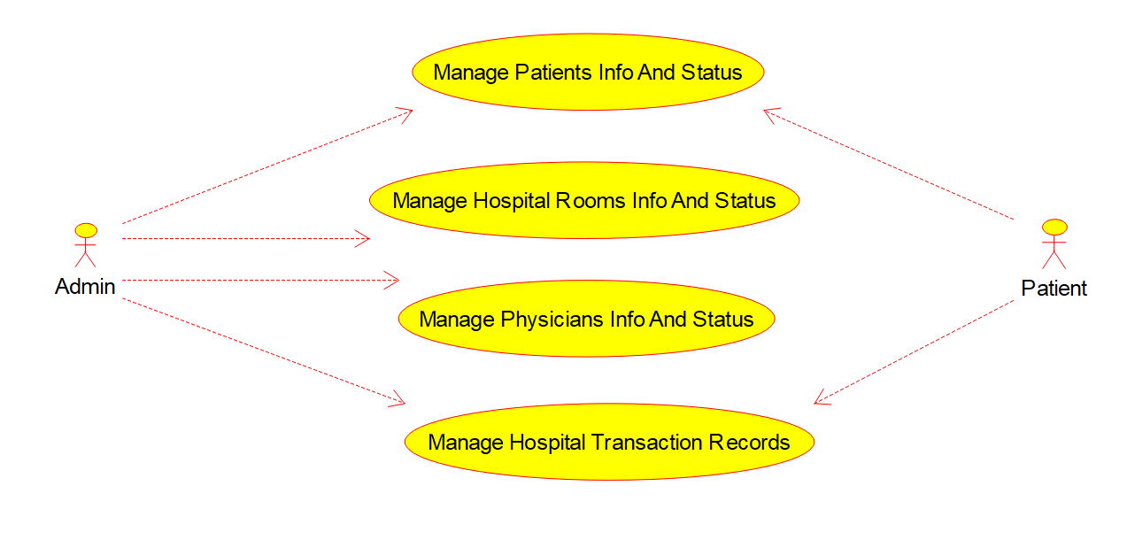

**RESUIT:**

USE-CASE Diagram for Online Hospital Management System successfully completed

**7.USE-CASE Diagram for ATM System**

**AIM:**

**TO IMPLIMENT AND EXECUTE ATM SYSTEM**

**OBJECTIVES:**

To access cash from an ATM, you just need to follow a few simple steps:

* Insert your debit or credit card into the ATM
* Confirm your identity by entering your personal identification number (PIN)
* Choose the account you want to withdraw funds from
* Select how much you want to withdraw
* Choose what type of bills you want, if this option is available. For example, you might choose to receive $100 as five $20 bills or two $50 bills.
* Confirm that you’re willing to pay the fee, if necessary
* Press OK and remove your debit or credit card
* Remove your cash from the ATM

The majority of ATMs in Canada only allow you to withdraw Canadian dollars. That said, some machines do offer U.S. dollars. You’ll also find a few ATMs that will allow you to withdraw other foreign currencies, but they’re usually only in airports.

Keep in mind that most financial institutions set a daily withdrawal limit, such as $1,000. However, you can call your bank and ask to have the limit increased if you’re planning to make a large withdraw

**PROCEDURE:**

*Arrange The Following characteristics

*Place persons at one side

*The elliptical shaped orbits place it in order

*Now give arrow ray to the characteristics

**OUTPUT:**

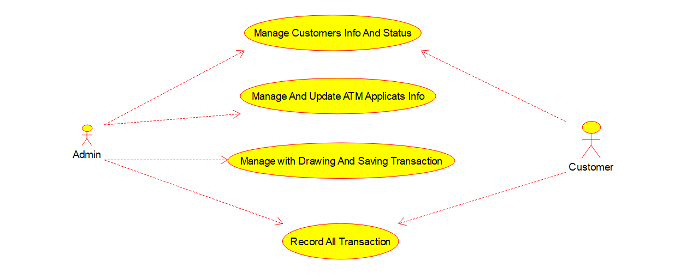

**RESULT:**

USE-CASE Diagram for ATM System successfully Completed

**8.USE-CASE Diagram For Online College Management System**

**AIM:**

TO IMPLEMENT AND EXECUTE ONLINE COLLEGE MANAGEMENT SYSTEM

**OBJECTIVES:**

The college management software is designed for:

* Colleges
* Universities
* Junior colleges

Besides, specialized institutes and vocational institutes can use this software within the ecosystem of the organization. The software also manages the special requirements of colleges and campuses. Teachers, students, admin, management teams, and parents can use it easily.

If implemented well, college management software can improve various processes and can improve efficiencies of various departments drastically. It can also help achieve business as well as academic goals faster by reducing expenses.

**PROCEDURE:**

*Arrange The Following characteristics

*Place persons at one side

*The elliptical shaped orbits place it in order

*Now give arrow ray to the characteristics

**OUTPUT:**

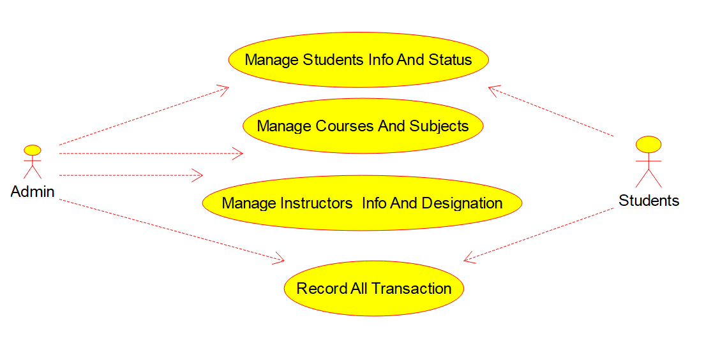

**RESULT:**

USE-CASE Diagram For Online College Management System Successfully Completed

**9.USE-CASE Diagram For Online Airline Reservation System**

**AIM:**

TO IMPLEMENT AND EXECUTE Online Airline Reservation System

**OBJECTIVES:**

This system is the subsystem of the airline reservation system. The actors are passengers, admins, and the banks that are the organizations.

The passenger is concerned with multiple use cases like login, check for availability, book ticket, etc. The book ticket use case is in relation to the choose seat use case. The admin cancels tickets, updates flight schedules. The bank sees the payment use cases.

**PROCEDURE:**

*Arrange The Following characteristics

*Place persons at one side

*The elliptical shaped orbits place it in order

*Now give arrow ray to the characteristics

**OUTPUT:**

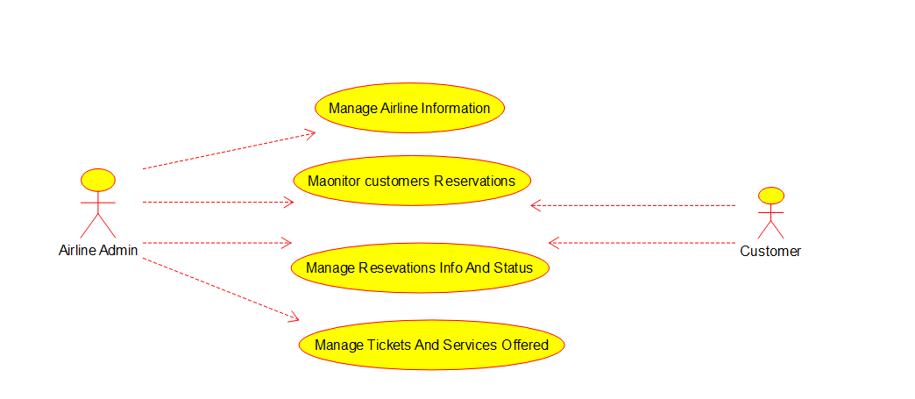

**RESULT:**

USE-CASE Diagram For Online Airline Reservation System Successfully Completed

**10.CLASS Diagram For Online Airline Reservation System**

**AIM:**

TO IMPLEMENT AND EXECUTE Online Airline Reservation System

**OBJECTIVES:**

This system is the subsystem of the airline reservation system. The actors are passengers, admins, and the banks that are the organizations.

The passenger is concerned with multiple use cases like login, check for availability, book ticket, etc. The book ticket use case is in relation to the choose seat use case. The admin cancels tickets, updates flight schedules. The bank sees the payment use cases.

**PROCEDURE:**

*Arrange The Following characteristics

*Place persons at one side

*The elliptical shaped orbits place it in order

*Now give arrow ray to the characteristics

**OUTPUT:**

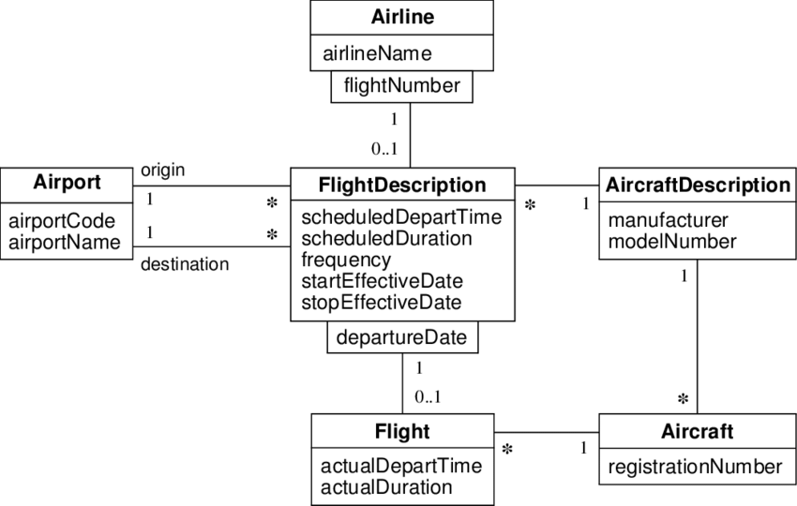

**RESULT:**

CLASS Diagram For Online Airline Reservation System Successfully Completed

**11.CLASS Diagram For Online Voting System**

AIM:

TO IMPLIMENT AND EXECUTE ONLINE VOTING SYSTEM

**OBJECTIVES:**

Online Voting is a web-based voting system that will help you manage your elections easily and securely. This voting system can be used for casting votes during the elections held in colleges, etc. In this system the voter do not have to go to the polling booth to cast their vote. They can use their personal computer to cast their votes. There is a database which is maintained in which all the name of the voters with their complete information is stored. The System Administrator registers the voters by simply filling a registration form to register the voters. After registration, the voter is assigned a secret voter ID with which he/she can use to login to the system and cast his/her vote. If invalid/wrong details are submitted, then the person is not registered to vote. After the user successfully registers themselves, a link is sent on their respective E-mail IDs. The link is a key for the activation of the account of the user. The account is activated only after the user clicks on that link. The site will be activated only on the day of voting. Once the user logs in, they will be provided with a One Time Password (OTP) which has to be entered by the user before casting his/her vote. The password will be destroyed after casting of their respective vote. A receipt of the vote will be sent to the user on their respective E-mail IDs. The advantage of online voting is that the voters have the choice of voting at their own free time and there is reduced congestion. It also minimizes on errors of vote counting. The individual votes are submitted in a database which can be queried to find out who of the aspirants for a given post has the highest number of votes.

**PROCEDURE:**

*Arrange The Following characteristics

*Place persons at one side

*The elliptical shaped orbits place it in order

*Now give arrow ray to the characteristics

**OUTPUT:**

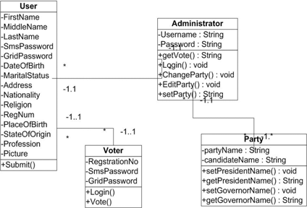

**RESULT:**

Thus, The Program Executed Successfully

**12.CLASS Diagram For Library Management System**

**AIM:**

TO IMPLEMENT AND EXECUTE LIBRARY MANAGEMENT SYSTEM

**OBJECTIVES:**

A library management system is software that is designed to manage all the functions of a library. It helps librarian to maintain the database of new books and the books that are borrowed by members along with their due dates.

This system completely automates all your library’s activities. The best way to maintain, organize, and handle countless books systematically is to implement a library management system software.

A library management system is used to maintain library records. It tracks the records of the number of books in the library, how many books are issued, or how many books have been returned or renewed or late fine charges, etc.

You can find books in an instant, issue/reissue books quickly, and manage all the data efficiently and orderly using this system. The purpose of a library management system is to provide instant and accurate data regarding any type of book, thereby saving a lot of time and effort

**PROCEDURE:**

*Arrange The Following characteristics

*Place persons at one side

*The elliptical shaped orbits place it in order

*Now give arrow ray to the characteristics

**OUTPUT:**

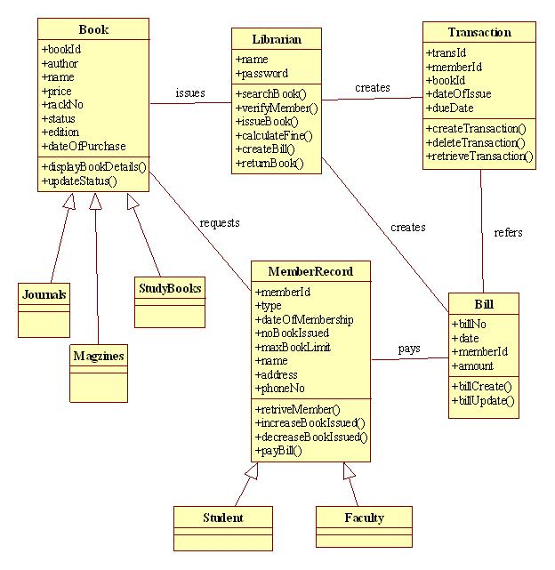

**RESULT:**

Thus, The Program Executed Successfully

**13.CLASS Diagram For Online Shopping System**

**AIM:**

TO IMPLEMENT AND EXECUTE ONLINE SHOPPING SYSTEM

**OBJECTIVES:**

 Use Case are intended to provide all stakeholders, including clients and project managers as well as develops and engineers, with a high-level view of the subject system and communicate the highest level system requirements in non-technical terms.

The purpose of use case diagrams is to model what the system should do without considering how it should be done at this stage ) and to view the use of the system from the user's perspective (**external view**) rather than internally (**implementation of these features).**

Use Case diagrams have only 4 major elements:

1. The **actors** that the system you are describing interacts with:
2. The **system**itself (system boundary - the rectangle)
3. The **use cases**, or services, that the system knows how to perform, and
4. The lines **(link)** that represent relationships between these elements.

**PROCEDURE:**

*Arrange The Following characteristics

*Place persons at one side

*The elliptical shaped orbits place it in order

*Now give arrow ray to the characteristics

**OUTPUT:**

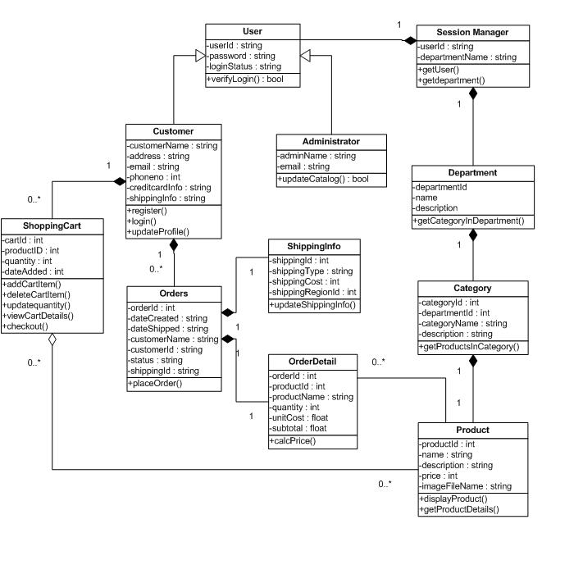

**RESULT:**

CLASS Diagram for online shopping system Successfully Completed

**14.CLASS Diagram For Online Railway Reservation System**

**AIM:**

TO IMPLEMENT AND EXECUTE THE ONLINE RAILWAY RESERVATION SYSTEM

**OBJECTIVES:**

Railway ticket booking system is implemented by [C programming](https://www.geeksforgeeks.org/c/). It is as same as one can see while we are going for online ticket booking. The following series of steps are being followed while booking a railway ticket in this software-

1. The first step is to provide the total number of passengers and submit all the necessary details of the passengers.
2. The next step is to enter the source and destination.
3. A list of available trains will appear. Among them, the user has to choose one.
4. The ticket value will be evaluated. The system will ask to enter the seat choice by showing the seat matrix. At last, a receipt will be generated on the screen.

DFD graphically speaking to the capacities, or cycles, which catch, control, store, and convey information between a framework and its current circumstance and between segments of a framework. The visual portrayal makes it a decent specialized device among User and System creator. Structure of DFD permits beginning from a wide outline and extend it to an order of definite charts. DFD has regularly been utilized because of the accompanying

**PROCEDURE:**

*Arrange The Following characteristics

*Place persons at one side

*The elliptical shaped orbits place it in order

*Now give arrow ray to the characteristics

**OUTPUT:**

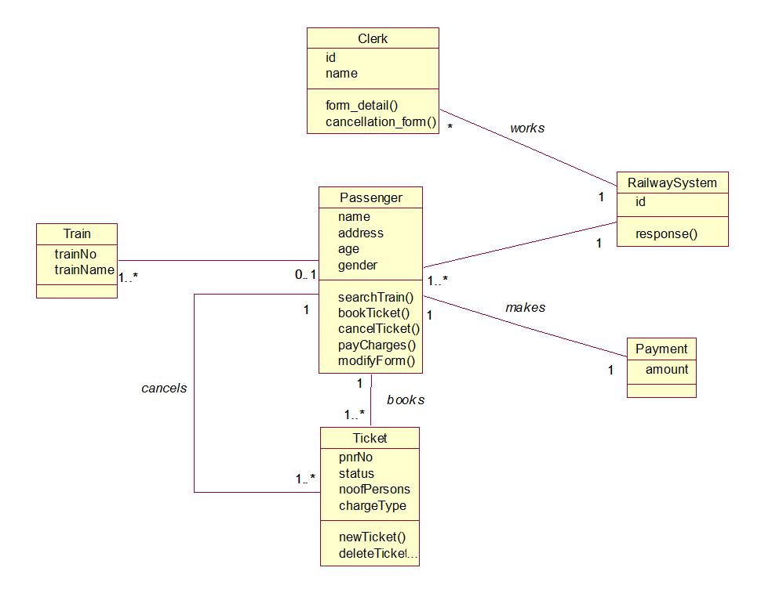

**RESULT:**

USE-CASE Diagram for Online Railway Reservation System successfully completed

**15.Activity Diagram For Online Voting System**

AIM:

TO IMPLIMENT AND EXECUTE ONLINE VOTING SYSTEM

**OBJECTIVES:**

Online Voting is a web-based voting system that will help you manage your elections easily and securely. This voting system can be used for casting votes during the elections held in colleges, etc. In this system the voter do not have to go to the polling booth to cast their vote. They can use their personal computer to cast their votes. There is a database which is maintained in which all the name of the voters with their complete information is stored. The System Administrator registers the voters by simply filling a registration form to register the voters. After registration, the voter is assigned a secret voter ID with which he/she can use to login to the system and cast his/her vote. If invalid/wrong details are submitted, then the person is not registered to vote. After the user successfully registers themselves, a link is sent on their respective E-mail IDs. The link is a key for the activation of the account of the user. The account is activated only after the user clicks on that link. The site will be activated only on the day of voting. Once the user logs in, they will be provided with a One Time Password (OTP) which has to be entered by the user before casting his/her vote. The password will be destroyed after casting of their respective vote. A receipt of the vote will be sent to the user on their respective E-mail IDs. The advantage of online voting is that the voters have the choice of voting at their own free time and there is reduced congestion. It also minimizes on errors of vote counting. The individual votes are submitted in a database which can be queried to find out who of the aspirants for a given post has the highest number of votes.

**PROCEDURE:**

*Arrange The Following characteristics

*Place persons at one side

*The elliptical shaped orbits place it in order

*Now give arrow ray to the characteristics

**OUTPUT:**

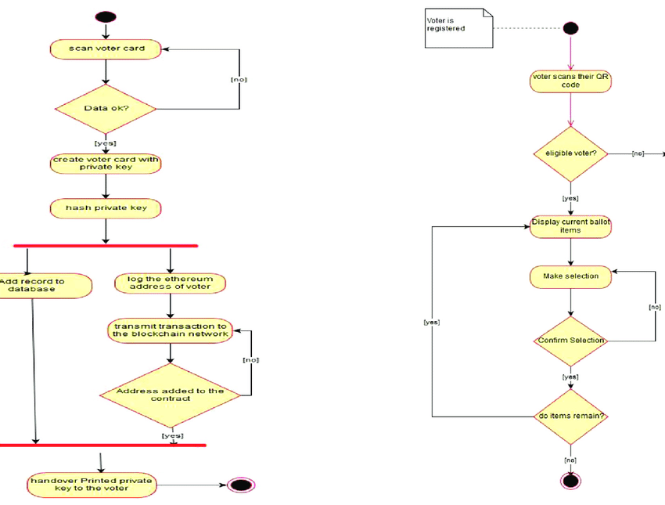

**RESULT:**

Activity Diagram For Voting System Completed Successfully

**16.Activity Diagram For Library Management System**

**AIM:**

TO IMPLEMENT AND EXECUTE LIBRARY MANAGEMENT SYSTEM

**OBJECTIVES:**

A library management system is software that is designed to manage all the functions of a library. It helps librarian to maintain the database of new books and the books that are borrowed by members along with their due dates.

This system completely automates all your library’s activities. The best way to maintain, organize, and handle countless books systematically is to implement a library management system software.

A library management system is used to maintain library records. It tracks the records of the number of books in the library, how many books are issued, or how many books have been returned or renewed or late fine charges, etc.

You can find books in an instant, issue/reissue books quickly, and manage all the data efficiently and orderly using this system. The purpose of a library management system is to provide instant and accurate data regarding any type of book, thereby saving a lot of time and effort

**PROCEDURE:**

*Arrange The Following characteristics

*Place persons at one side

*The elliptical shaped orbits place it in order

*Now give arrow ray to the characteristics

**OUTPUT:**

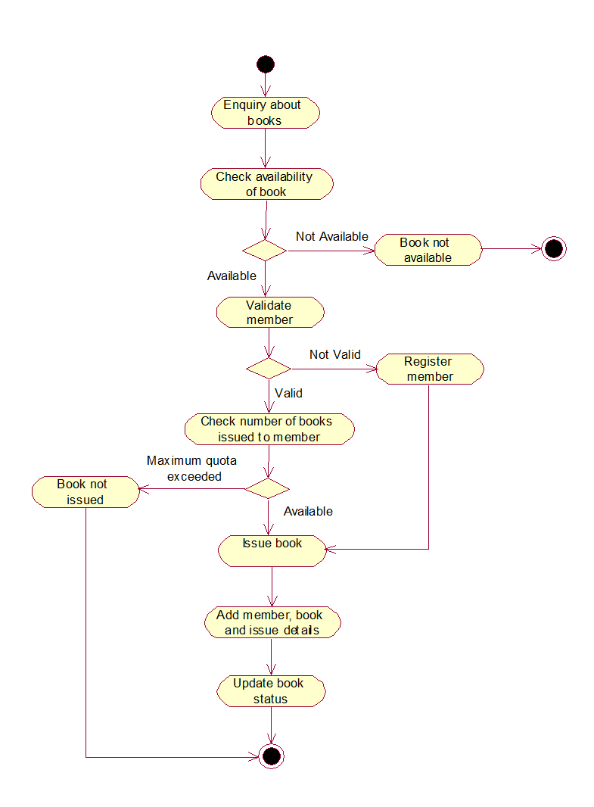

**RESULT:**

Activity Diagram For Library Management System Completed Successfully

**17.Activity Diagram For Online Shopping System**

**AIM:**

TO IMPLEMENT AND EXECUTE ONLINE SHOPPING SYSTEM

**OBJECTIVES:**

 Use Case are intended to provide all stakeholders, including clients and project managers as well as develops and engineers, with a high-level view of the subject system and communicate the highest level system requirements in non-technical terms.

The purpose of use case diagrams is to model what the system should do without considering how it should be done at this stage ) and to view the use of the system from the user's perspective (**external view**) rather than internally (**implementation of these features).**

Use Case diagrams have only 4 major elements:

1. The **actors** that the system you are describing interacts with:
2. The **system**itself (system boundary - the rectangle)
3. The **use cases**, or services, that the system knows how to perform, and
4. The lines **(link)** that represent relationships between these elements.

**PROCEDURE:**

*Arrange The Following characteristics

*Place persons at one side

*The elliptical shaped orbits place it in order

*Now give arrow ray to the characteristics

**OUTPUT:**

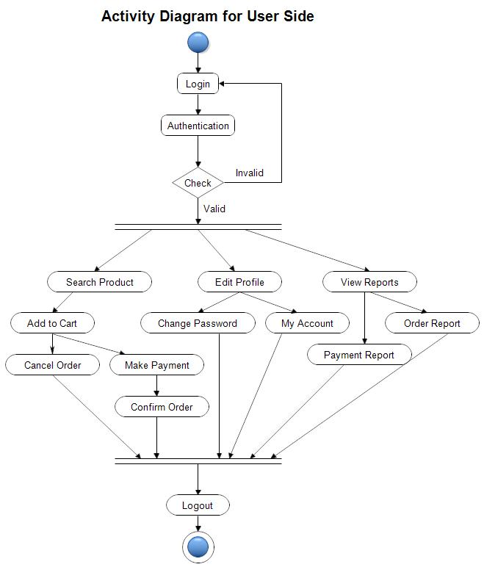

**RESULT:**

Activity Diagram for online shopping system Successfully Completed

**18.Activity Diagram For Online Railway Reservation System**

**AIM:**

TO IMPLEMENT AND EXECUTE THE ONLINE RAILWAY RESERVATION SYSTEM

**OBJECTIVES:**

Railway ticket booking system is implemented by [C programming](https://www.geeksforgeeks.org/c/). It is as same as one can see while we are going for online ticket booking. The following series of steps are being followed while booking a railway ticket in this software-

1. The first step is to provide the total number of passengers and submit all the necessary details of the passengers.
2. The next step is to enter the source and destination.
3. A list of available trains will appear. Among them, the user has to choose one.
4. The ticket value will be evaluated. The system will ask to enter the seat choice by showing the seat matrix. At last, a receipt will be generated on the screen.

DFD graphically speaking to the capacities, or cycles, which catch, control, store, and convey information between a framework and its current circumstance and between segments of a framework. The visual portrayal makes it a decent specialized device among User and System creator. Structure of DFD permits beginning from a wide outline and extend it to an order of definite charts. DFD has regularly been utilized because of the accompanying

**PROCEDURE:**

*Arrange The Following characteristics

*Place persons at one side

*The elliptical shaped orbits place it in order

*Now give arrow ray to the characteristics

**OUTPUT:**

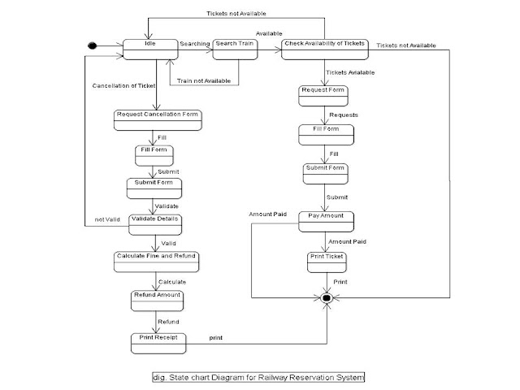

**RESULT:**

USE-CASE Diagram for Online Railway Reservation System successfully completed

**19.Activity Diagram For Hospital Management System**

**AIM:**

TO IMPLIMENT AND EXECUTE THE HOSPITAL MANAGEMENT SYSTEM

**OBJECTIVES:**

HMS was introduced to solve the complications coming from managing all the paper works of every patient associated with the various departments of hospitalization with confidentiality. HMS provides the ability to manage all the paperwork in one place, reducing the work of staff in arranging and the paperwork of the patients. HMS does many works like:

* Maintain the medical records of the patient
* Maintain the contact details of the patient
* Keep track of the appointment dates
* Save the insurance information for later reference

Tracking the bill payments

The implementation of hospital management system project provides the institution with different advantages that improve the service quality and efficiency. As mentioned above it is created for three groups of users: patients, hospital staff and management, and third-parties like drug suppliers and insurance companies. The interaction between them conveys the general performance. The benefits received by a certain group of users also positively influence the work of the others. Cooperation and communication are the fundamental requirements here.

**PROCEDURE:**

*Arrange The Following characteristics

*Place persons at one side

*The elliptical shaped orbits place it in order

*Now give arrow ray to the characteristics

**OUTPUT:**

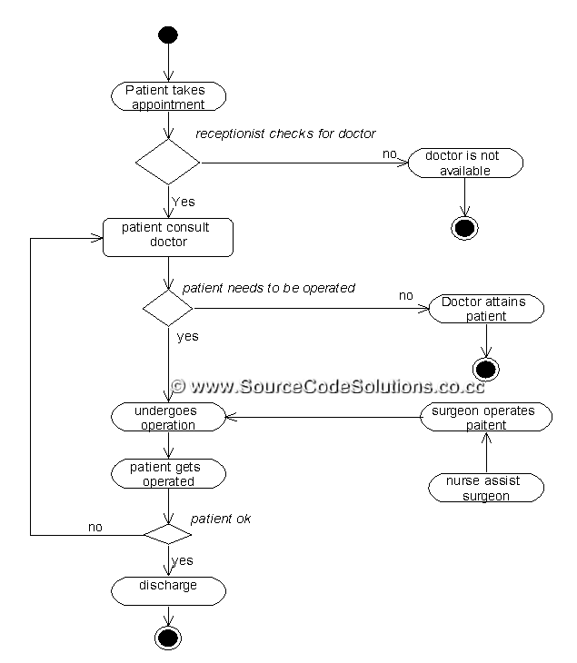

**RESULT:**

Thus, The Program Executed Successfully

**20.Raptor -Palindrome Or Not**

**AIM:**

A Flow chat Whether The Number Is Palindrome Or Not

**OBJECTIVES:**

Raptor allows the user to write and execute the program using flowcharts. The simple language and geographical components of raptor are designed to teach the major ideas of computer programming to the students .it is typically used in academics to teach introductory programming as well

**PROCEDURE:**

**STEP 1:** From the raptor software application dragging the icons of assignment input and output

**STEP 2:**Iam taking 5 assignments ,1 input and 2 output and 2 loop for the effective running of the program

**STEP 3:**Filling the assignment, input and output and loop columns to run the code and entering the 2 value to run the program

**OUTPUT:**

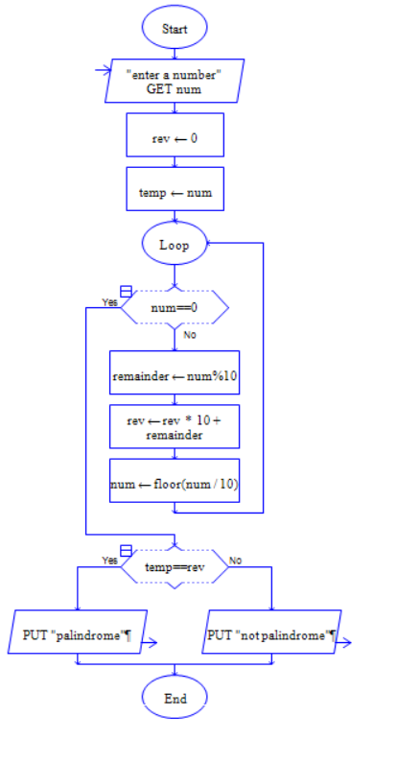

**RESULT:**

Finally the program is executed successfully

**21.FLOW Chat to calculate Fibonacci series**

**AIM:**

A Flow chat to calculate Fibonacci series

**OBJECTIVES:**

Raptor allows the user to write and execute the program using flowcharts. The simple language and geographical components of raptor are designed to teach the major ideas of computer programming to the students .it is typically used in academics to teach introductory programming as well

**PROCEDURE:**

**STEP 1:** From the raptor software application dragging the icons of assignment input and output

**STEP 2:**Iam taking 5 assignments ,1 input and 2 output and 2 loop for the effective running of the program

**STEP 3:**Filling the assignment, input and output and loop columns to run the code and entering the 2 value to run the program

**OUTPUT:**

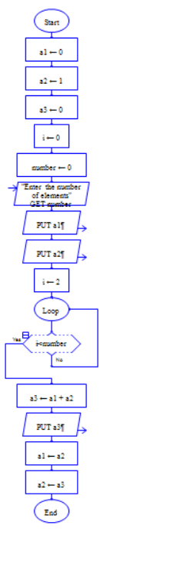

**RESULT:**

Finally the program is executed successfully

**22. Flow Chart To Swap Two Characters**

**AIM:**

A Flow chat to swap two characters

**OBJECTIVES:**

Raptor allows the user to write and execute the program using flowcharts. The simple language and geographical components of raptor are designed to teach the major ideas of computer programming to the students .it is typically used in academics to teach introductory programming as well

**PROCEDURE:**

**STEP 1:** From the raptor software application dragging the icons of assignment input and output

**STEP 2:**Iam taking 5 assignments ,1 input and 2 output and 2 loop for the effective running of the program

**STEP 3:**Filling the assignment, input and output and loop columns to run the code and entering the 2 value to run the program

**OUTPUT:**

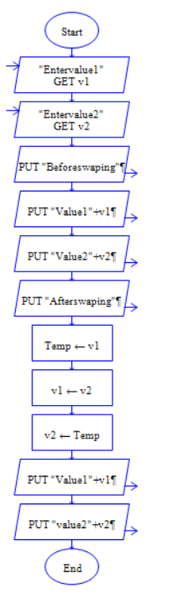

**RESULT:**

Finally the program is executed successfully

**23. Flow Chart To Display The Length Of The String**

**AIM:**

A Flow chat to display the length of the string

**OBJECTIVES:**

Raptor allows the user to write and execute the program using flowcharts. The simple language and geographical components of raptor are designed to teach the major ideas of computer programming to the students .it is typically used in academics to teach introductory programming as well

**PROCEDURE:**

**STEP 1:** From the raptor software application dragging the icons of assignment input and output

**STEP 2:**Iam taking 5 assignments ,1 input and 2 output and 2 loop for the effective running of the program

**STEP 3:**Filling the assignment, input and output and loop columns to run the code and entering the 2 value to run the program

**OUTPUT:**

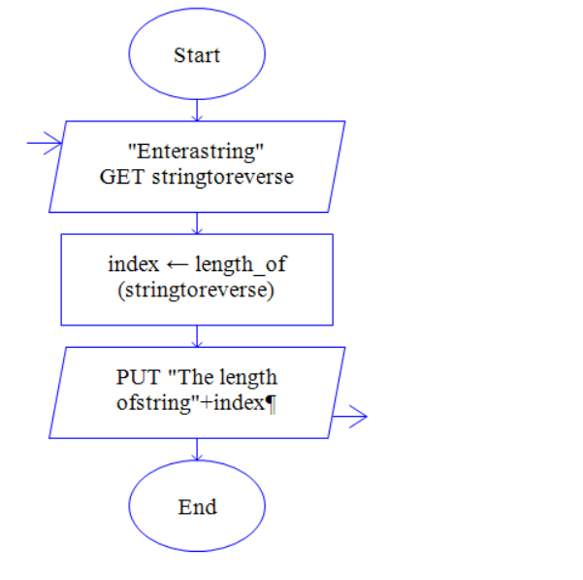

**RESULT:**

Finally the program is executed successfully

**24.Flowchat To Find Whether It Is Prime OR Not**

**AIM:**

A Flow chat to find whether it is prime or not

**OBJECTIVES:**

Raptor allows the user to write and execute the program using flowcharts. The simple language and geographical components of raptor are designed to teach the major ideas of computer programming to the students .it is typically used in academics to teach introductory programming as well

**PROCEDURE:**

**STEP 1:** From the raptor software application dragging the icons of assignment input and output

**STEP 2:**Iam taking 5 assignments ,1 input and 2 output and 2 loop for the effective running of the program

**STEP 3:**Filling the assignment, input and output and loop columns to run the code and entering the 2 value to run the program

**OUTPUT:**

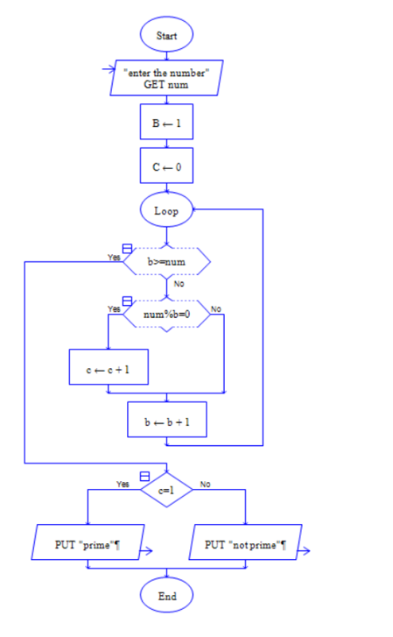

**RESULT:**

Finally the program is executed successfully

**25.CYCLOMATIC COMPLEXITY**

**AIM:**

A Flow chat to find whether it is prime or not

**OBJECTIVES:**

Raptor allows the user to write and execute the program using flowcharts. The simple language and geographical components of raptor are designed to teach the major ideas of computer programming to the students .it is typically used in academics to teach introductory programming as well

**PROCEDURE:**

**STEP 1:** From the raptor software application dragging the icons of assignment input and output

**STEP 2:**Iam taking 5 assignments ,1 input and 2 output and 2 loop for the effective running of the program

**STEP 3:**Filling the assignment, input and output and loop columns to run the code and entering the 2 value to run the program

**OUTPUT:**

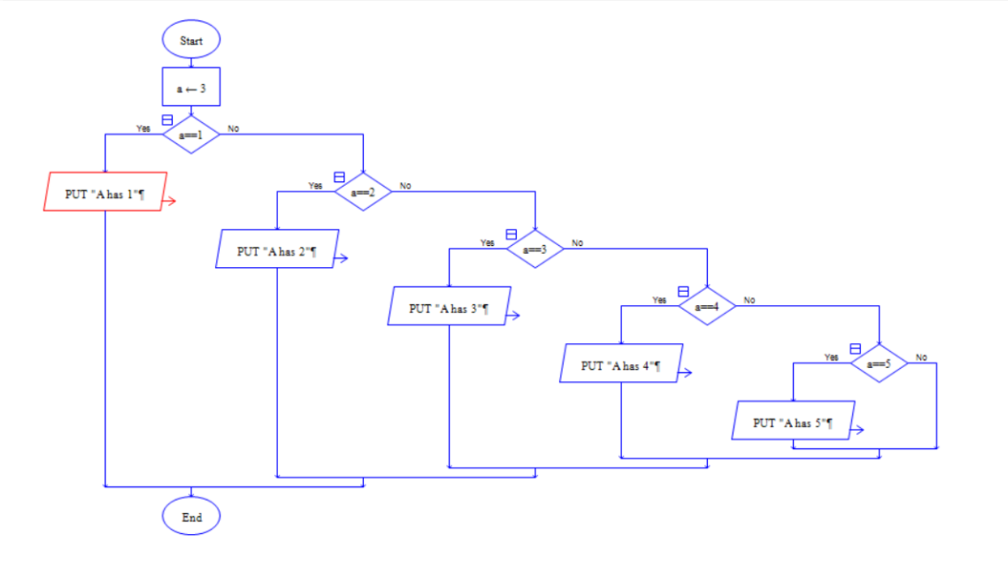

**RESULT:**

Finally the program is executed successfully